Gelen Evrak Tarih Sayı: 25.03.2024 - 12327
From: KUBİLAY ŞİMŞEK
Sent: Mon, 25 Mar 2024 11:12:53 +0000
To: ebys
Subject: FW: PROCUREMENT NOTICE - SRILANKAN AIRLINES LTD OF SRI LANKA
Attachments: image001.png, Tender Advertisement for SriLankan Airlines - CPIT-ICB 132023_.pdf

From: INFO <info@tobb.org.tr>
Sent: Monday, March 25, 2024 2:08 PM
To: KUBİLAY ŞİMŞEK <kubilay.simsek@tobb.org.tr>
Subject: İlt: PROCUREMENT NOTICE - SRILANKAN AIRLINES LTD OF SRI LANKA

Gönderen: prot@srilanka.org.tr <prot@srilanka.org.tr>
Gönderildi: 25 Mart 2024 Pazartesi 12:10
Kime: INFO
Konu: PROCUREMENT NOTICE - SRILANKAN AIRLINES LTD OF SRI LANKA

KONU: İHALE BİLDİRİMİ – SRILANKA HAVAYOLLARI LTD (REF NO: CPIT/ICB 13/2023)

Sayın Beyefendi/Hanımefendi,

Sri Lanka Büyükelçiliği, bu belge ile birlikte Sri Lanka Havayolları LTD tarafından yayınlanan ihale ilanının bir kopyasını da göndermek istemektedir. Bu nedenle Sri Lanka, uluslararası üne sahip üreticilerden, yurtdışındaki Akredite İhracat Acentelerinden veya Sri Lanka'daki Akredite Yerel Acentelerinden kapalı teklifleri davet etmektedir.

Büyükelçilik Türk şirketlerinin katılımını desteklemektedir.

Ekte daha fazla bilgiye ulaşabilirsiniz.

Teşekkürler

Saygılarımla

SUBJECT: PROCUREMENT NOTICE - SRILANKAN AIRLINES LTD (REF NO: CPIT/ICB 13/2023)

Dear Sir/Madam,

The Embassy of Sri Lanka would like to send the copy of the tender notice published by Srilankan Airlines LTD of Sri Lanka along with this document. Therefore, Sri Lanka invites sealed bids from internationally renowned manufacturers, their Accredited Export Agents abroad or their Accredited Local Agents in Sri Lanka.

The Embassy supports the participation of Turkish companies.

There is more information in the appendix.

Thanks

Sincerely

Embassy of Sri Lanka
Gaziosmanpaşa, Kırlangıç Sokak No. 41,
Çankaya/ Ankara
Tel: +90 312 427 10 21

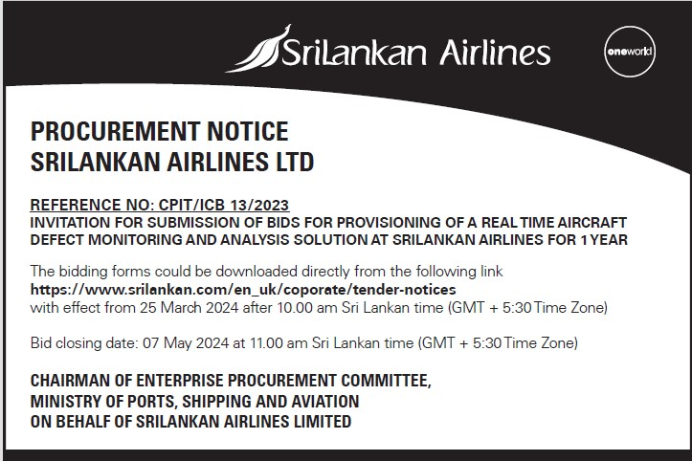

SRILANKAN AIRLINES LTD
PROCUREMENT NOTICE

1. REFERENCE NO: CPIT/ICB 13/2023

INVITATION FOR SUBMISSION OF BIDS FOR PROVISIONING OF A REAL TIME AIRCRAFT DEFECT MONITORING AND ANALYSIS
SOLUTION AT SRILANKAN AIRLINES FOR 1 YEAR

The bidding forms could be downloaded directly from the following link https://www.srilankan.com/en_uk/coporate/tender-notices
with effect from 25 March 2024 after 10.00 am Sri Lankan time (GMT + 5:30 Time Zone)
Bid closing date: 07 May 2024 at 11.00 am Sri Lankan time (GMT + 5:30 Time Zone)

Chairman of Enterprise Procurement Committee,
Ministry of Ports, Shipping and Aviation
On behalf of
SriLankan Airlines Limited

